**Questions 1 and 2: ACT scores, part 1**

The ACT is a standardized college admissions test used in the United States. The four multi-part questions in this assessment all involve simulating some ACT test scores and answering probability questions about them.

For the three year period 2016-2018, [ACT standardized test scores](http://www.act.org/content/act/en/products-and-services/the-act/scores/national-ranks.html) were approximately normally distributed with a mean of 20.9 and standard deviation of 5.7. (Real ACT scores are integers between 1 and 36, but we will ignore this detail and use continuous values instead.)

First we'll simulate an ACT test score dataset and answer some questions about it.

Set the seed to 16, then use **rnorm** to generate a normal distribution of 10000 tests with a mean of 20.9 and standard deviation of 5.7. Save these values as **act_scores**. You'll be using this dataset throughout these four multi-part questions.

**(IMPORTANT NOTE! If you use R 3.6 or later, you will need to use the command set.seed(x, sample.kind = "Rounding") instead of set.seed(x). Your R version will be printed at the top of the Console window when you start RStudio.)**

**Question 1a**

1.0/1.0 point (graded)

What is the mean of act_scores? correct

20.9 Loading

You have used 1 of 10 attempts Some problems have options such as save, reset, hints, or show answer. These options follow the Submit button.

**Question 1b**

1.0/1.0 point (graded)

What is the standard deviation of act_scores? correct

5.675 Loading

You have used 3 of 10 attempts Some problems have options such as save, reset, hints, or show answer. These options follow the Submit button.

**Question 1c**

1.0/1.0 point (graded)

A perfect score is 36 or greater (the maximum reported score is 36).

In act_scores, how many perfect scores are there out of 10,000 simulated tests? correct

41 Loading

You have used 1 of 10 attempts Some problems have options such as save, reset, hints, or show answer. These options follow the Submit button.

**Question 1d**

1.0/1.0 point (graded)

In act_scores, what is the probability of an ACT score greater than 30? correct

0.0527 Loading

You have used 1 of 10 attempts Some problems have options such as save, reset, hints, or show answer. These options follow the Submit button.

**Question 1e**

1.0/1.0 point (graded)

In act_scores, what is the probability of an ACT score less than or equal to 10? correct

0.0282 Loading

You have used 1 of 10 attempts Some problems have options such as save, reset, hints, or show answer. These options follow the Submit button.

**Question 2**

1/1 point (graded)

Set x equal to the sequence of integers 1 to 36. Use dnorm to determine the value of the probability density function over x given a mean of 20.9 and standard deviation of 5.7; save the result as f_x. Plot x against f_x.

Which of the following plots is correct?

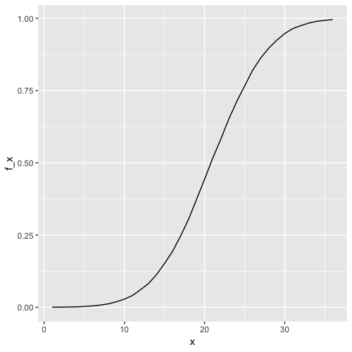

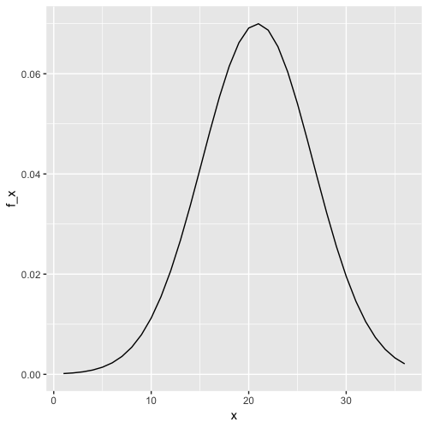

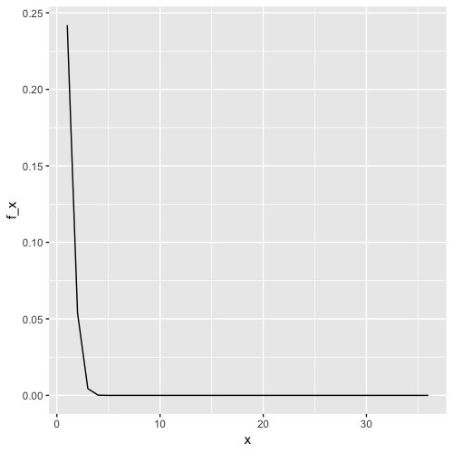

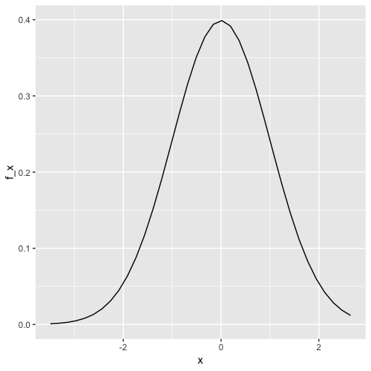

correct

You have used 1 of 2 attempts Some problems have options such as save, reset, hints, or show answer. These options follow the Submit button.